SRS Document Development and GitHub

Nicholi D’Amato
The University of Arizona Global Campus
CST 499: Capstone for Computer Software Technology
Instructor: Joseph Rangitsch
April 11, 2024
GitHub Profile:
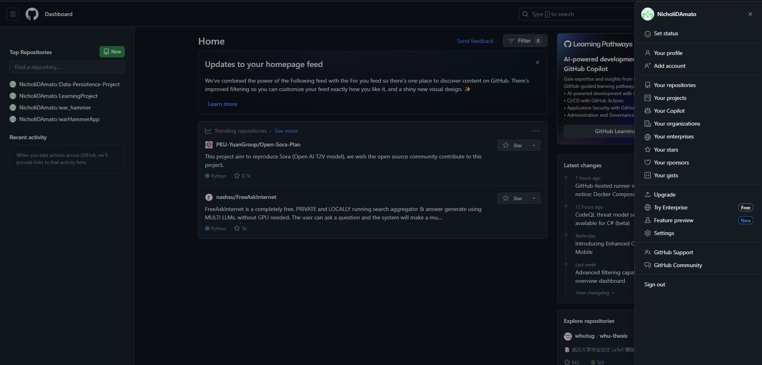
https://github.com/NicholiDAmato

Software Requirements Specification
for
Student Enrollment
Version 1.0 approved
Prepared by Nicholi D’Amato
UAGC
4-11-2024
Table of Contents
Table of Contents ii
Revision History ii
1. Introduction 1
1.1 Purpose 1
1.2 Document Conventions 1
1.3 Intended Audience and Reading Suggestions 1
1.4 Product Scope 1
1.5 References 1
2. Overall Description 2
2.1 Product Perspective 2
2.2 Product Functions 2
2.3 User Classes and Characteristics 2
2.4 Operating Environment 2
2.5 Design and Implementation Constraints 2
2.6 User Documentation 2
2.7 Assumptions and Dependencies 3
3. External Interface Requirements 3
3.1 User Interfaces 3
3.2 Hardware Interfaces 3
3.3 Software Interfaces 3
3.4 Communications Interfaces 3
4. System Features 4
4.1 System Feature 1 4
4.2 System Feature 2 (and so on) 4
5. Other Nonfunctional Requirements 4
5.1 Performance Requirements 4
5.2 Safety Requirements 5
5.3 Security Requirements 5
5.4 Software Quality Attributes 5
5.5 Business Rules 5
6. Other Requirements 5
Appendix A: Glossary 5
Appendix B: Analysis Models 5
Appendix C: To Be Determined List 6

Revision History
Name | Date | Reason For Changes | Version
Person’s Name, not “Company X”. Multiple people are okay if they all worked on this version

Introduction

Purpose
We need the ability for students to be able to self-register for classes to manage their own schedule and reduce the workload of staff in the registrar.

Document Conventions
It is assumed that any required infrastructure for the website already exists or will be created without specifically calling it out in this document.

Intended Audience and Reading Suggestions
Intended readers are project champions and members of the management of the registrar office. Starting with the scope and the use cases would be best.

Developers can read the use cases and requirements.

Product Scope
Building a class registration website will allow for students to self-manage their schedule and course load to allow reduction of work in the registrar’s office. It will also allow students to have better response times on their desires to handle their course concerns.

References
None.

Overall Description

Product Perspective
<Describe the context and origin of the product being specified in this SRS. For example, state whether this product is a follow-on member of a product family, a replacement for certain existing systems, or a new, self-contained product. If the SRS defines a component of a larger system, relate the requirements of the larger system to the functionality of this software and identify interfaces between the two. A simple diagram that shows the major components of the overall system, subsystem interconnections, and external interfaces can be helpful.>

Product Functions
- Users can register with the site.
- Users can login
- Users can see a list of classes.
  - Users can register for those classes.
  - Users can withdraw from classes.

User Classes and Characteristics
- Students
  - Can manage their own courses.
- Administrators
  - To be added later but can manage all courses and wait lists.

Operating Environment
The website is expected to be functional on Chrome and Safari.

Design and Implementation Constraints
- Website will only be available in English.

User Documentation
Likely users could get by with only tooltips.

Assumptions and Dependencies
<List any assumed factors (as opposed to known facts) that could affect the requirements stated in the SRS. These could include third-party or commercial components that you plan to use, issues around the development or operating environment, or constraints. The project could be affected if these assumptions are incorrect, are not shared, or change. Also identify any dependencies the project has on external factors, such as software components that you intend to reuse from another project, unless they are already documented elsewhere (for example, in the vision and scope document or the project plan).>

You may have some or None. Think about it though, if you write “none”, but it is obvious you should have some, I will deduct points!

External Interface Requirements

User Interfaces
<Describe the logical characteristics of each interface between the software product and the users. This may include sample screen images, any GUI standards or product family style guides that are to be followed, screen layout constraints, standard buttons and functions (e.g., help) that will appear on every screen, keyboard shortcuts, error message display standards, and so on. Define the software components for which a user interface is needed. Details of the user interface design should be documented in a separate user interface specification.>

Think about this in terms of standards, not specific features. For example,
- all buttons will have a black border
- all fonts will be Arial
- Draw a screen template showing “main area”, “menu here”, “status bar” and describe each component. If you have multiple screen layouts depending on the user’s current task/settings, describe them
- What screen resolutions will you support?
- Will you be Section 508 compliant? Are there any other standards you support?
- etc…

Hardware Interfaces
<Describe the logical and physical characteristics of each interface between the software product and the hardware components of the system. This may include the supported device types, the nature of the data and control interactions between the software and the hardware, and communication protocols to be used.>

If you system doesn’t include hardware, then you’ll have none. If it has hardware components, then you should describe (at a high level) how you interface with that hardware.

Software Interfaces
<Describe the connections between this product and other specific software components (name and version), including databases, operating systems, tools, libraries, and integrated commercial components. Identify the data items or messages coming into the system and going out and describe the purpose of each. Describe the services needed and the nature of communications. Refer to documents that describe detailed application programming interface protocols. Identify data that will be shared across software components. If the data sharing mechanism must be implemented in a specific way (for example, use of a global data area in a multitasking operating system), specify this as an implementation constraint.>

These are internal connections to things like databases, web servers. You mainly need to explain that you have them, but (for CS421) I don’t expect detailed information about how you actually connect to them and use them. Just explain that you do connect to them and use them for storage of customer information, or to process incoming web requests, etc… These are internal components of your system.

Communications Interfaces
<Describe the requirements associated with any communications functions required by this product, including e-mail, web browser, network server communications protocols, electronic forms, and so on. Define any pertinent message formatting. Identify any communication standards that will be used, such as FTP or HTTP. Specify any communication security or encryption issues, data transfer rates, and synchronization mechanisms.>

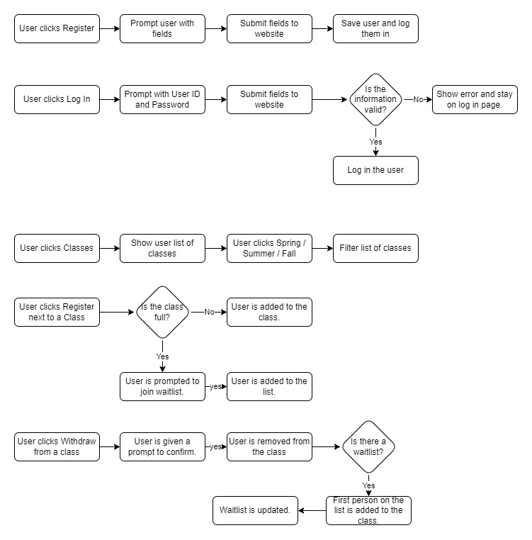
These are external communication mechanisms. Do you connect to a bank computer to verify credit card information? That is NOT part of your system, so it is an external communication you have. Describe it here. Do you have other systems connecting in to yours to perform some function? That would also go here.

System Use Cases

Register a User
- Objective – User should be able to register with the website and unlock additional features.
- Priority – High
- Source – Carl Gnome (marketing)
- Actors – Customer, central bank computer
- Flow of Events
  - Basic Flow
    - Customer clicks ‘Register’
    - Prompted with required fields.
    - Registered with the website.
  - Alternative Flow 1 – If required information is not available.
    - An error message is shown to the user.
  - Exception Flow 1 – User attempts to register an already registered username.
    - An error message is shown to the user.

- Includes
- Preconditions – User has not logged in.
- Post conditions – User is registered in the database.
- Notes/Issues –
  - Each new user should have a unique ID associated with a password. The system should guard against two users using the same ID for registration.
  - Profiles must include some key information about the applicant including name, phone, email, and any other information you may see necessary.

Login a User
- Objective – User should be able to login after being registered.
- Priority – High
- Source – Carl Gnome (marketing)
- Actors – Customer, central bank computer
- Flow of Events
  - Basic Flow
    - Customer clicks ‘Log In
    - Prompted with User ID and Password
    - Logged in to website.
  - Alternative Flow 1 – Wrong User ID and Password combination.
    - An error message is shown to the user.
  - Exception Flow
- Includes
- Preconditions –
  - User has not logged in.
  - User has already registered.
- Post conditions – User is logged in.
- Notes/Issues –
  - Post registration, users can login to the system at any time using the ID and the password created during the registration process.

List Classes by Semester
- Objective – User can see a list of classes offered by semester.
- Priority – High
- Source – Carl Gnome (marketing)
- Actors – Customer, central bank computer
- Flow of Events
  - Basic Flow
    - Customer clicks ‘Classes’
    - Taken to list of classes with option for Spring / Summer / Fall
  - Alternative Flow 1 – User selects Spring / Summer / Fall
    - Classes are filtered to those classes.
  - Exception Flow
- Includes
- Preconditions –
- Post conditions –
- Notes/Issues –
  - Online courses run through three semesters per year (spring/summer/fall), and students can list the courses that will be offered during any semester, as not all courses will be offered in every semester.

Register for a Class
- Objective – Users can register for classes.
- Priority – High
- Source – Carl Gnome (marketing)
- Actors – Customer, central bank computer
- Flow of Events
  - Basic Flow
    - User selects ‘Classes’.
    - User selected ‘Register’ on a class.
    - User added to the class roster.
  - Alternative Flow 1 – Class is full.
    - User is prompted to be added to the wait list.
    - User confirms, the user is added to the wait list.
  - Exception Flow
- Includes
- Preconditions –
  - User has not logged in.
  - User has already registered.
- Post conditions – User is logged in.
- Notes/Issues –
  - Each course should have a maximum number of enrollments that may be different depending on the course.
  - If a user wants to enroll into a course and the course is full, the student can add themselves onto a waiting list.

Withdraw from a Class
- Objective – Users can withdraw from registered classes.
- Priority – medium
- Source – Carl Gnome (marketing)
- Actors – Customer, central bank computer
- Flow of Events
  - Basic Flow
    - User selects ‘Classes’.
    - User selected ‘Withdraw on a class they are already registered for.
    - User is prompted for confirmation.
    - User is removed from the class roster or waitlist.
  - Exception Flow
- Includes
- Preconditions –
  - User has logged in.
  - User has already enrolled in a class.
- Post conditions – User is removed from the class.
- Notes/Issues –
  - A user can also cancel the enrollment from any course that they are enrolled in, and the system should inform the first in the waiting list (if any) that they can enroll into the class.

Manage Waitlist
- Objective – Waitlists should automatically scale and move students as seats become available.
- Priority – Low
- Source – Carl Gnome (marketing)
- Actors – Customer, central bank computer
- Flow of Events
  - Basic Flow
    - A user withdraws from a class that has a waiting list.
    - The first user on the list is added to the class.
    - All other users move up on the waiting list.
  - Exception Flow
- Includes
- Preconditions –
  - Class has a waiting list.
  - A student in that class withdraws from it.
- Post conditions –
  - Users are registered in the class.
  - Waitlist is updated.
- Notes/Issues –

Other Nonfunctional Requirements

Performance Requirements
<If there are performance requirements for the product under various circumstances, state them here and explain their rationale, to help the developers understand the intent and make suitable design choices. Specify the timing relationships for real time systems. Make such requirements as specific as possible. You may need to state performance requirements for individual functional requirements or features.>

Safety Requirements
<Specify those requirements that are concerned with possible loss, damage, or harm that could result from the use of the product. Define any safeguards or actions that must be taken, as well as actions that must be prevented. Refer to any external policies or regulations that state safety issues that affect the product’s design or use. Define any safety certifications that must be satisfied.>

Security Requirements
<Specify any requirements regarding security or privacy issues surrounding use of the product or protection of the data used or created by the product. Define any user identity authentication requirements. Refer to any external policies or regulations containing security issues that affect the product. Define any security or privacy certifications that must be satisfied.>

Software Quality Attributes
<Specify any additional quality characteristics for the product that will be important to either the customers or the developers. Some to consider are: adaptability, availability, correctness, flexibility, interoperability, maintainability, portability, reliability, reusability, robustness, testability, and usability. Write these to be specific, quantitative, and verifiable when possible. At the least, clarify the relative preferences for various attributes, such as ease of use over ease of learning.>

Other Requirements
A database will be required to store user information, class information, wait lists.

System Requirements Chart
< Include a table in this section with the following columns:

ID – Unique requirement ID
Priority – Priority of this requirement
Type – Functional(F) or Non-functional(NF)
Source – Who is most interested in this requirement (John Smith – Customer). For this project you can make it up, in reality you’ll want to capture this as you capture the requirements.
Contained in Use Case(s) – Which use cases reference this requirement or which use cases when executed will perform this requirement. There may be a few functional requirements without a use-case and the non-functional requirements generally will NOT be part of a use-case (so put N/A).
Description – The description of the requirement. “The system shall …. “
>

Appendix A: Glossary
<Define all the terms necessary to properly interpret the SRS, including acronyms and abbreviations. You may wish to build a separate glossary that spans multiple projects or the entire organization, and just include terms specific to a single project in each SRS.>
Appendix B: Analysis Models
<Optionally, include any pertinent analysis models, such as data flow diagrams, class diagrams, state-transition diagrams, or entity-relationship diagrams.>

Don’t do any of these for CS421 SRS. You will create these models during the high level design deliverable.
Appendix C: To Be Determined List
<Collect a numbered list of the TBD (to be determined) references that remain in the SRS so they can be tracked to closure.>

List here any open questions or things you know still need to be done to the SRS, but haven’t been addressed yet. (It’s okay to have things like that, especially in this CS421 project because we don’t have time to do everything.)

References:
Tsui, F., Karam, O., & Bernal, B. (2018). Essentials of software engineering (4th ed.). Jones & Bartlett Learning.

